*P525/1*

Name………………………………………………………..Signature………………….

*CHEMISTRY*

*Paper 1*

*MAY 2024*

*2 ¾ hours*

PRE MOCK EXAMINATIONS SET 1 2024

UGANDA ADVANCED CERTIFICATE OF EDUCATION

SENIOR SIX

CHEMISTRY

Paper 1

2 hours 45 minutes

***Instructions to candidates:***

* Attempt **all** questions in section A and any **six** from section B
* All questions are to be answered in the spaces provided
* A periodic table with relevant atomic masses is supplied at the end of the paper.

|  |  |  |  |  |  |  |  |  |  |  |  |  |  |  |  |  |  |
| --- | --- | --- | --- | --- | --- | --- | --- | --- | --- | --- | --- | --- | --- | --- | --- | --- | --- |
| **FOR** **Examiner’s use only** | | | | | | | | | | | | | | | | | |
| 1 | 2 | 3 | 4 | 5 | 6 | 7 | 8 | 9 | 10 | 11 | 12 | 13 | 14 | 15 | 16 | 17 | TOTAL |
|  |  |  |  |  |  |  |  |  |  |  |  |  |  |  |  |  |  |

**SECTION A (46 MARKS)**

Answer **all** questions in this section

1. (a) Define the term enthalpy of formation. (1 mark)

……………………………………………………………………………………………………………………………………………………………………………………………………………………………………………………………………….............................................................

(b) Calculate the enthalpy of formation sodium chloride from the following data.

ΔHθ (Kjmol – 1) (3 marks)

Na(s) Na(g) +109

Cl2(g) 2Cl(g) +242

Na+(g) + Cl – (g) NaCl(s) −771

Cl(g) + e – Cl – (g) −364

…………………………………………………………………………………………………………………………………………………………………………………………………………

…………………………………………………………………………………………………………………………………………………………………………………………………………

…………………………………………………………………………………………………………………………………………………………………………………………………………

…………………………………………………………………………………………………………………………………………………………………………………………………………

(c) Comment on the stability of sodium chloride. Give a reason for your answer.

(1 mark)

…………………………………………………………………………………………………………………………………………………………………………………………………………

…………………………………………………………………………………………………………………………………………………………………………………………………………

1. Complete the following reactions and in each case write the 1UPAC names of the major organic product. (1 ½ marks each)
2. CH3 MnO4 –(aq)│

heat

…………………………………………………………………………………………………………………………………………………………………………………………………………

1. BrCH2CHCH2CH2Br │EtOH

│ Heat

CH3

…………………………………………………………………………………………………………………………………………………………………………………………………………

1. CH3 CHC ≡ CH + H2  Lindlar’s catalyst

│

CH3

…………………………………………………………………………………………………………………………………………………………………………………………………..

1. Cr(NH3)63+ and Co(CN)42- are complexes formed when Cr3+ (aq) and Co2+ (aq) ions are respectively treated with excess ammonia and potassium thiocynate .
2. Name the above complexes. (02 marks)

……………………………………………………………………………………………………………………………………………………………………………………………………………………………………………………….

1. Complete the table below by filling in the oxidation state and coordination number of the central atoms of the above complexes. (02 marks)

|  |  |  |
| --- | --- | --- |
| Complex ion | Oxidation state | Coordination number |
| Cr(NH3)63+ |  |  |
| Co(CN)42- |  |  |

1. (a) Write the formula of the hydrides of sodium and sulphur, in each case state the type of bonds present in the compounds. (2 marks)

|  |  |  |
| --- | --- | --- |
| Elements | Formula of hydride | Type of bond |
| Sodium |  |  |
| Sulphur |  |  |

(b) Write equations to show how the hydrides react with water. (3 marks)

…………………………………………………………………………………………………………………………………………………………………………………………………………

…………………………………………………………………………………………………………………………………………………………………………………………………………

1. (a) Define the term Osmotic pressure. (1 mark)

…………………………………………………………………………………………………………………………………………………………………………………………………………

……………………………………………………………………………………………………

(b) A polysaccharide has the formula (C12H12O11)n. A solution containing 5.00gdm– 3 of the sugar has an osmotic pressure of 7.12 x 102 Nm – 2 at 20oC. Find the value of n. (3 ½ marks)

…………………………………………………………………………………………………………………………………………………………………………………………………………

…………………………………………………………………………………………………………………………………………………………………………………………………………

…………………………………………………………………………………………………………………………………………………………………………………………………………

…………………………………………………………………………………………………………………………………………………………………………………………………………

1. State any two assumptions made in (b) above. (1 mark)

………………………………………………………………………………………………………………………………………………………………………………………………………………………………………………………………………………………………………………

1. A powdered element T was investigated as shown in the table below

|  |  |
| --- | --- |
| Experiment | Results |
| 1. A mixture of T and lead (IV) oxide was heated | A colourless gas with a chocking smell and turned acidified potassium dichromate from orange to green was evolved. |
| 1. Concentrated nitric acid is added to heated T, the products were diluted and barium nitrate solution added. | T dissolved in nitric acid with effervescence of a brown gas. On addition of barium nitrate solution a white precipitate was formed |

1. Identify T (1 mark)

…………………………………………………………………………………………………………………………………………………………………………………………………………

1. Write equations for the reactions in experiments (a) and (b) (4 marks)

……………………………………………………………………………………………………………………………………………………………………………………………………………………………………………………………………………………………………………………………………………………………………………………………………………………

…………………………………………………………………………………………………………………………………………………………………………………………………………

1. (a) 20cm3 of hydrocarbon Q with general formula CnH2n – 2 were mixed with 100cm3 of oxygen. The mixture was ignited and the residual gaseous product at room temperature bubbled through concentrated potassium hydroxide solution. The final volume was found to be 20cm3 .
2. Calculate the value of n in Q. (2 marks)

……………………………………………………………………………………………………………………………………………………………………………………………………………………………………………………………………………………………………………………………………………………………………………………………………………………

……………………………………………………………………………………………………

1. Deduce the molecular formula of Q. ( ½ mark)

…………………………………………………………………………………………………………………………………………………………………………………………………………

(b) Q has two isomers X and Y. X decolourises bromine water but it does not react with ammoniacal silver nitrate solution. Y forms a white precipitate with ammoniacal silver nitrate solution.

(i) Identify isomers X and Y (1 mark)

…………………………………………………………………………………………………………………………………………………………………………………………………………

……………………………………………………………………………………………………

(ii) Write an equation for the reaction between (1 mark)

X and bromine water

…………………………………………………………………………………………………………………………………………………………………………………………………………

Y and ammoniacal silver nitrate solution. (1 mark)

……………………………………………………………………………………………………

……………………………………………………………………………………………………

1. Name the reagent(s) that can be used to distinguish between each of the following compounds. State what would be observed in each case.
2. KI(aq) and KCl(aq) (1 ½ marks)

Reagent(s)

……………………………………………………………………………………………………………………………………………………………………………………………………

Observations

…………………………………………………………………………………………………………………………………………………………………………………………………………………………………………………………………………………………………………………………………………………………………………………………………………

1. COONa and OH (1 ½ marks)

Reagent(s)

……………………………………………………………………………………………………………………………………………………………………………………………………

Observations

……………………………………………………………………………………………………………………………………………………………………………………………………

……………………………………………………………………………………………………………………………………………………………………………………………………

1. PbCO3(s) and BaCO3(s) (1 ½ marks)

Reagent(s)

……………………………………………………………………………………………………………………………………………………………………………………………………

Observations

……………………………………………………………………………………………………………………………………………………………………………………………………

……………………………………………………………………………………………………………………………………………………………………………………………………

1. (a)Draw the structure and state the shape of each of the following species in the table below. (4 marks)

|  |  |  |
| --- | --- | --- |
| Species | Structure | Shape |
| 1. SO3 |  |  |
| 1. PO3-4 |  |  |
| 1. CrO42- |  |  |

1. State what would be observed and write equation for the reaction when species in (iii) above is reacted with dilute sulphuric acid. (02 marks)

………………………………………………………………………………………………………………………………………………………………………………………………………………………………………………………..

**SECTION B: (54 MARKS)**

**Answer only six questions from this section**

10. Write equations to show how the following conversions can be effected. Indicate all reagents and conditions necessary for each reaction.

1. 1 – methylcyclobutene to 2 – methyl cyclobutanol. (3 marks)

…………………………………………………………………………………………………………………………………………………………………………………………………………………………………………………………………………………………………………………………………………………………………………………………………………

1. From benzene and bromomethane (4 marks)

C – NH CH3

O

…………………………………………………………………………………………………………………………………………………………………………………………………………………………………………………………………………………………………………………………………………………………………………………………………………

……………………………………………………………………………………………………………………………………………………………………………………………………

……………………………………………………………………………………………………………………………………………………………………………………………………

1. Butane – 2, − diol to 2,3 –butane dionedioxime. (2 marks)

…………………………………………………………………………………………………………………………………………………………………………………………………………………………………………………………………………………………………………………………………………………………………………………………………………

1. (a) Be(OH)2, Mg(OH)2, Ca(OH)2 and Ba(OH)2 are the hydroxides of group II elements. Briefly describe how the metals react with ;
2. sodium hydroxide solution (2 marks)

……………………………………………………………………………………………………………………………………………………………………………………………………………………………………………………………………………………………………………………………………………………………………………………………………………………

1. hydrochloric acid (2 marks)

…………………………………………………………………………………………………………………………………………………………………………………………………………………………………………………………………………………………………………………………………………………………………………………………………………

(b) The solubilities of the hydroxides of group II elements of the periodic table at 25oC are given below

|  |  |  |  |  |  |
| --- | --- | --- | --- | --- | --- |
| Hydroxide | Be(OH)2 | Mg(OH)2 | Ca(OH)2 | Sr(OH)2 | Ba(OH)2 |
| Solubility g/100g of water | Insoluble | 0.002 | 0.150 | 0.900 | 4.000 |

1. State and explain the trend in solubility of the hydroxides.

……………………………………………………………………………………………………………………………………………………………………………………………………………………………………………………………………………………………………………………………………………………………………………………………………………………………………………………………………………………………………………………………………………………………………………………………………………………………………………………………………………………………………………………………………………………………………………………………………………………

1. Different masses of solid Ca(OH)2 and Ba(OH)2 containing the **same number** **of moles** were separately shaken with the same volume of water at 25oC. Identify the solution with higher pH value. Give a reason for your answer

(1 ½ marks)

………………………………………………………………………………………………………………………………………………………………………………………………………………………………………………………………………………………………………

1. (a) The partition coefficient of ammonia between water and trichloromethane at 25oC is 25.0,

(i) Define the term partition coefficient. (1 ½ marks)

…………………………………………………………………………………………………………………………………………………………………………………………………………………………………………………………………………………………………………………………………………………………………………………………………………

(ii) State two conditions under which the partition coefficient (KD = 25.0) is valid other than constant temperature. (1 mark)

…………………………………………………………………………………………………………………………………………………………………………………………………………………………………………………………………………………………………………………………………………………………………………………………………………

(b) 25cm3 of 0.0056M nickel (II) sulphate solution were added to an **equal** volume of ammonia solution at 25oC. The mixture was shaken with 50cm3 of trichloromethane and allowed to stand until equilibrium was established. The trichloromethane layer required 32cm3 of 0.0025M hydrochloric acid for complete neutralization. 7.060cm3 of the aqueous layer required 20cm3 of 0.02M hydrochloric acid. Nickel (II) ions react with ammonia according to the equation;

Ni2+(aq) + nNH3(aq) [Ni(NH3)n]2+(aq)

Calculate

1. Molar concentration of the free ammonia in the aqueous layer.(2 marks)

……………………………………………………………………………………………………………………………………………………………………………………………………………………………………………………………………………………………………………………………………………………………………………………………………………………………………………………………………………………………………………………………………………………………………………………………………………………………………………………………………………………………………………………………………………………………………………………………………………………

1. Molar concentration of ammonia that reacted with nickel (II) ions (2 marks)

…………………………………………………………………………………………………………………………………………………………………………………………………………………………………………………………………………………………………………………………………………………………………………………………………………………………………………………………………………………………………………………………………………………………………………………………………………………………………………………………………………………………………………………

1. Use your answer b (II) above to determine the value of n in [Ni(NH3)n]2+. (2 marks)

…………………………………………………………………………………………………………………………………………………………………………………………………………………………………………………………………………………………………………………………………………………………………………………………………………………..

1. (a) Describe a simple chemical test to distinguish between CH3COCH3 and CH3CH2CHO (2 marks)

…………………………………………………………………………………………………………………………………………………………………………………………………………………………………………………………………………………………………………………………………………………………………………………………………………………..

(b) Compound Z can be synthesized by the reaction between X and Y as shown below

CH3CH2CHO Step I X

O

Step III CH3CH2C

OCH(CH3)2

CH3COCH3 Step II Y

1. Identify compounds X and Y (1 mark)

…………………………………………………………………………………………………………………………………………………………………………………………………………

1. Name the type of reaction that occurs in steps I and I (1 mark)

……………………………………………………………………………………………………

(c) Identify the reagents and state the conditions necessary for the reaction in

(i) step I (1 mark)

…………………………………………………………………………………………………………………………………………………………………………………………………………………..

(ii) step III (2 marks)

…………………………………………………………………………………………………………………………………………………………………………………………………………………..

1. Write the mechanism for the reaction that occurs in step III (2 marks)

………………………………………………………………………………………………………………………………………………………………………………………………………………………………………………………………………………………………………………………………………………………………………………………………………………………………………………………………………………………………………………………………………………………………………………………………………………………………

1. Explain each of the following observations. (a) An aqueous solution of sodium sulphite when mixed with ammonium chloride produce a colourless gas that forms dense white fumes with concentrated hydrochloric acid on warming. (3 marks)

…………………………………………………………………………………………………………………………………………………………………………………………………………………………………………………………………………………………………………………………………………………………………………………………………………………………………………………………………………………………………………………………………………………………………………………………………………………………………………………………………………………………………………………………………………………………………………………………………………………………………………

(b) The acid dissociation constant (Ka) of chloric (1) acid is lower than the Ka for chloric (VII) acid at 25oC, (2 marks)

…………………………………………………………………………………………………………………………………………………………………………………………………………………………………………………………………………………………………………………………………………………………………………………………………………………………………………………………………………………………………………………………………………………………………………………………………………………………………………………………………………………………………………………………………………………………………………………………………………………………………………

1. When refluxed with aqueous potassium hydroxide followed by acidified silver nitrate solution. Chloroethane forms a white precipitate while chlorobenzene gives no observable change. (4 mark)

……………………………………………………………………………………………………………………………………………………………………………………………………………………………………………………………………………………………………………………………………………………………………………………………………………………………………………………………………………………………………………………………………………………………………………………………………………………………………………………………………………………………………………………………………………………………………………………………………………………

1. HF, HCl, HBr and HI are hydrides of group VII elements
2. Explain the variation in boiling points of the hydrides. (3 marks)

……………………………………………………………………………………………………………………………………………………………………………………………………………………………………………………………………………………………………………………………………………………………………………………………………………………………………………………………………………………………………………………………………………………………………………………………………………………………………………………………………………………

1. Aqueous solutions of the hydrides of the same concentration at constant temperature have different pH values.
2. Identify the hydride whose solution in water has the lowest pH (1 mark)

……………………………………………………………………………………………………………………………………………………………………………………………………

1. Give a reason for your answer in b(i) above. (2 marks)

……………………………………………………………………………………………………………………………………………………………………………………………………………………………………………………………………………………………………………………………………………………………………………………………………………………………………………………………………………………………………………………………………………………………………………………………………………

1. Write an equation for the reaction between
2. The hydride of fluorine and excess silicon (IV) oxide (1 mark)

……………………………………………………………………………………………………………………………………………………………………………………………………

1. Potassium manganate (VII) solution and the hydride of chlorine. (1 mark)

……………………………………………………………………………………………………………………………………………………………………………………………………

1. Concentrated sulphuric acid and the hydride of bromine. ` (1 mark)

……………………………………………………………………………………………………………………………………………………………………………………………………

1. The rate equation for a reaction between substances A, B and C is of the form, Rate = k [A]x[B]y[C]z where x+y+z = 3. The following data were obtained in a series of experiments at a constant temperature.

|  |  |  |  |  |
| --- | --- | --- | --- | --- |
| Experiment | [A]/ moldm-3 | [B]/ moldm-3 | [C]/ moldm-3 | Rate (moldm-3s-1) |
| 1 | 0.10 | 0.20 | 0.20 | 8.0x10-5 |
| 2 | 0.10 | 0.05 | 0.20 | 2.0x 10-5 |
| 3 | 0.05 | 0.20 | 0.20 | 2.0x 10-5 |
| 4 | 0.10 | 0.10 | 0.10 | T |

1. What do you understand by the term rate equation? (1 mark)

………………………………………………………………………………………………………………………………………………………………………………………………………………………………………………………..

1. Determine the order of reaction with respect to
2. A, B and C (3 marks)

…………………………………………………………………………………………………………………………………………………………………………………………………………………………………………………………………………………………………………………………………………………………………………………………………

1. Determine the rate constant and indicate its units. (2 marks)

……………………………………………………………………………………………………………………………………………………………………………………………………………………………………….

1. Determine the value of T. (1 mark)  
   ………………………………………………………………………………………………………………………………………………………..
2. What would happen to the rate of reaction when the concentration of B is halved, C is doubled and A is left constant? (1 mark)

………………………………………………………………………………………………………………………………………………………..

1. Explain how addition of a catalyst will affect the rate of reaction. (1 mark)

……………………………………………………………………………………………………………………………………………………………………………………………………………………………………………………..

1. A mixture of methanol and water at 50oC is an ideal solution. The partial vapour pressure of methanol in the vapour above the solution varies according to Raoult’s law as shown in the table below.

|  |  |  |  |  |  |
| --- | --- | --- | --- | --- | --- |
| Partial vapour pressure of methanol (mmHg) | 40.0 | 100.0 | 200.0 | 260.0 | 320.0 |
| Mole fraction of methanol in solution | 0.10 | 0.25 | 0.50 | 0.65 | 0.80 |

1. (i) Define the term ideal solution. (1 mark)

………………………………………………………………………………………………………………………………………………………………………………………………………………………………………………………………………………………………………………

(ii) State Raoult’s law (1 mark)

………………………………………………………………………………………………………………………………………………………………………………………………………………………………………………………………………………………………………

1. On the same axes, plot a graph of;
2. Vapour pressure of methanol
3. Total vapour pressure above the solution against mole fraction of methanol.

(The composition of methanol in the vapour is 50% when its mole fraction in solution is 0.19)

1. Use your graphs in (b) above to determine the
2. Saturated vapour pressure of methanol at 50oC. (1 mark)

…………………………………………………………………………………………………

1. Saturated vapour pressure of water at 50oC

…………………………………………………………………………………………………

1. Compare the volatility of methanol and water at 50oC. Give a reason for your answer. (1 mark)

……………………………………………………………………………………………………………………………………………………………………………………………………



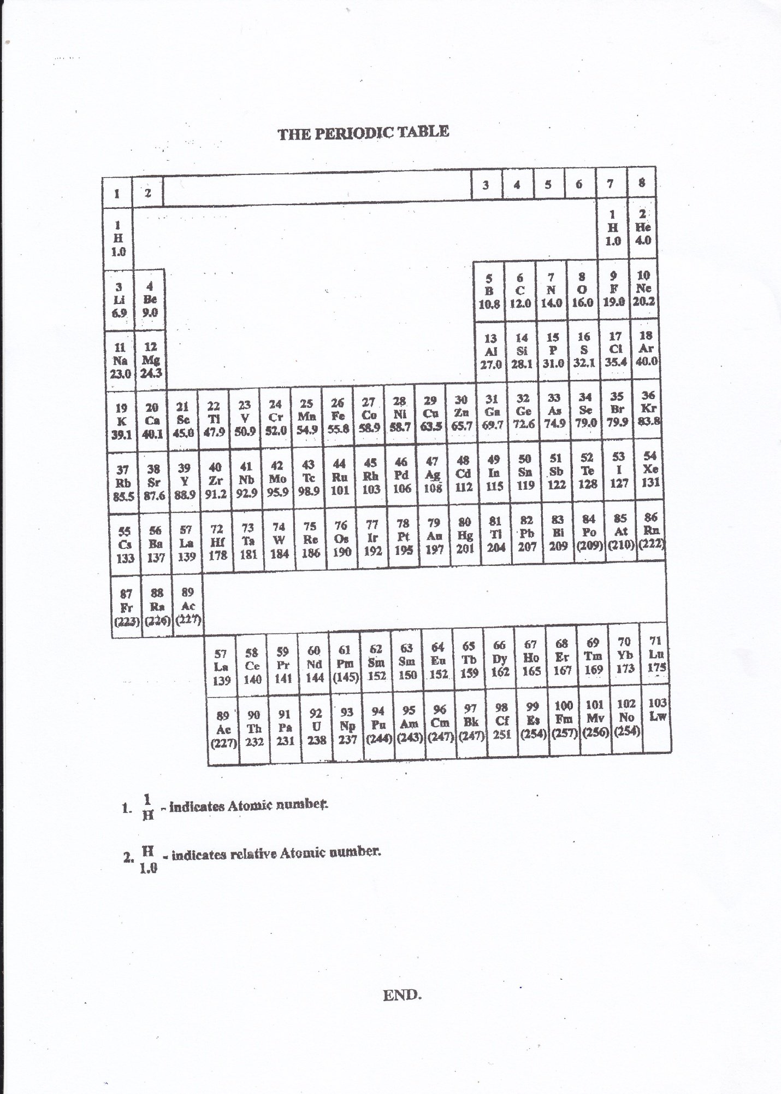**END**